(Approx. 533 words)

Chromebook Update
By Jeff Wilkinson, President
Sun City Summerlin Computer Club
https://www.scscc.club
pres.scscc (at) gmail.com

I have become more interested in Chromebooks as an alternative for our club members who need to replace an outdated desktop or laptop computer. Many, if not most, of these users don’t need the features of today’s typical laptops and since so many of the tasks are accomplished online without the need for local storage, a Chromebook becomes a very attractive option. With a Chromebook and a free Google account; email, web browsing, video streaming and a host of Android applications are available.

In addition to its comparatively low cost, a Chromebook offers a useful synergy with Android phones and applications along with light weight and long battery life. The complete Google Suite of Cloud applications is available free and offers a useful alternative to Office software suites.

Another attraction is the ability to repurpose outdated laptops with the installation of Google’s Neverware CloudReady software. The free Home version listed as being “useful for Tinkerers, Parents and Students, and Other Humans Ready for a better OS” was right up my alley. I successfully converted two old laptops that were not upgradable to the current Windows operating system. Both worked well although they had some limitations. With a new HP Chromebook I was able to make use of all the latest features of the Chromebook operating system including one of the latest updates for scanning. By simply logging into my Google account with my Gmail address and password I had all my browsing bookmarks, photos and Gmail available to me.

So, when I saw a recent news report about the tracking of Chromebook users it raised some concern. As has been discussed before, an inquiry about a specific product or service, more often than not, results in the sudden appearance of ads for that product or service or similar products in many of your search results, popups on YouTube views, social media pages and emails. The gist of the new report I saw was the concern for the profiling of Chromebook users and the use of the collected information to target market to that user. The main way of collecting the metrics used to target market are cookies that are ostensibly used to “customize” your web experience. While a “do not track” setting is available in the Chrome and Edge browsers, be aware of this official Google statement “Most websites and web services, including Google’s, don’t change their behavior when they receive a Do Not Track request”. Chrome doesn’t provide details of which websites and web services respect Do Not Track requests and how websites interpret them. Do Not Track is not available on iPhones or iPads.
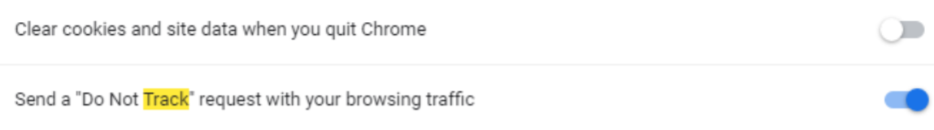
Does it work? Not very well … seems every time I search for anything, I get pop ups and ads for that or similar items for days. Of course, the data collection is true of virtually all the so-called free software in which your usage data is the real product. So be aware, while Chromebooks offer an attractive alternative to a Windows or IOS laptop they tightly integrate with Google in ways you may not realize.

https://www.usatoday.com/videos/tech/2018/09/25/-google-chrome-tracking-you/37935707/
https://clark.com/technology/google-chrome-do-not-track/
https://www.pcmag.com/how-to/how-to-get-google-to-quit-tracking-you
https://www.wired.com/story/google-tracks-you-privacy/
https://9to5google.com/2020/02/06/google-chrome-x-client-data-tracking/
https://lifehacker.com/what-data-of-mine-does-chrome-send-to-google-5763452

